**OS LAB 05**

Name: Shaheryar Siddqui Id: FA17-BECE-0023

TASK1:

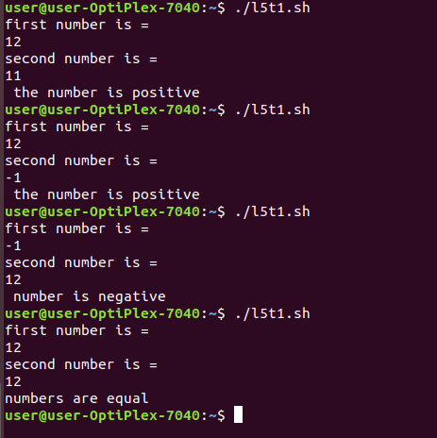

TASK2:

